TRADER(ORACLE)

1. You need to sign in with your trader login credentials.

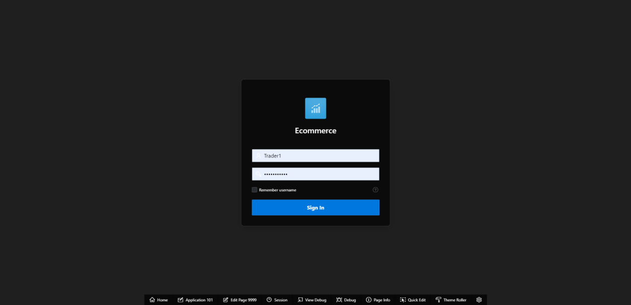

1. Once correct login credentials are filled, it will take you to your Oracle Apex dashboard with Reports, which will look like this. And you can only view your dashboard. You cannot view dashboard of other traders and Admin.

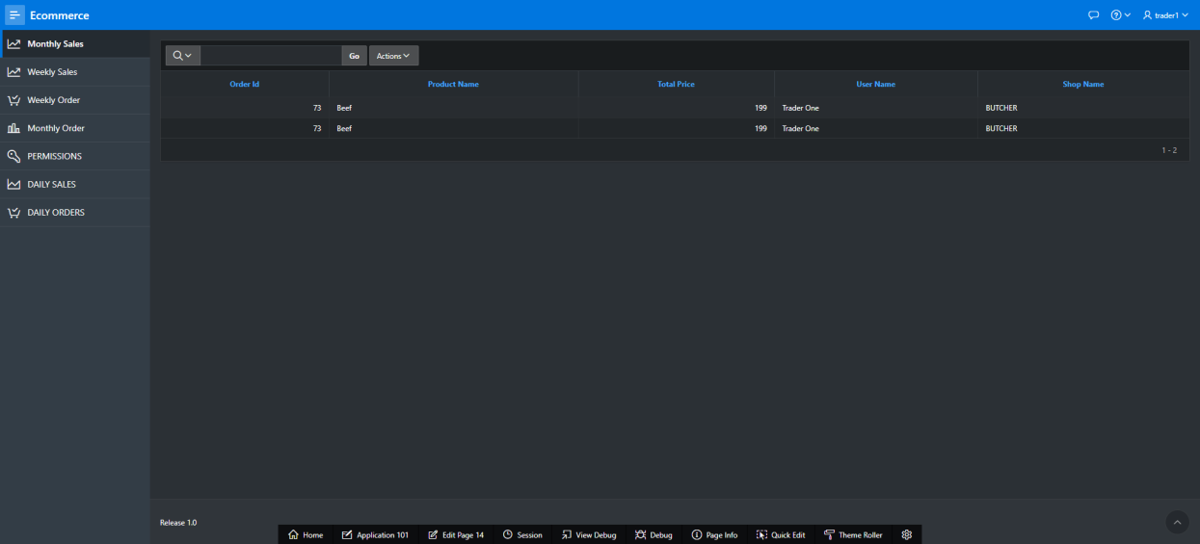

1. You have access to view your weekly sales, click on weekly sales. Weekly sales shows the details of the products that are sold within a week.

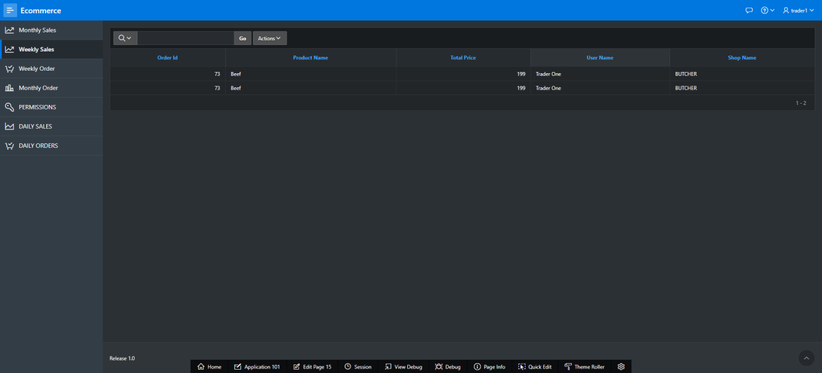

1. To view Weekly Order report, click on weekly order. Weekly order report shows the details of the product that are ordered by the customer in a week.

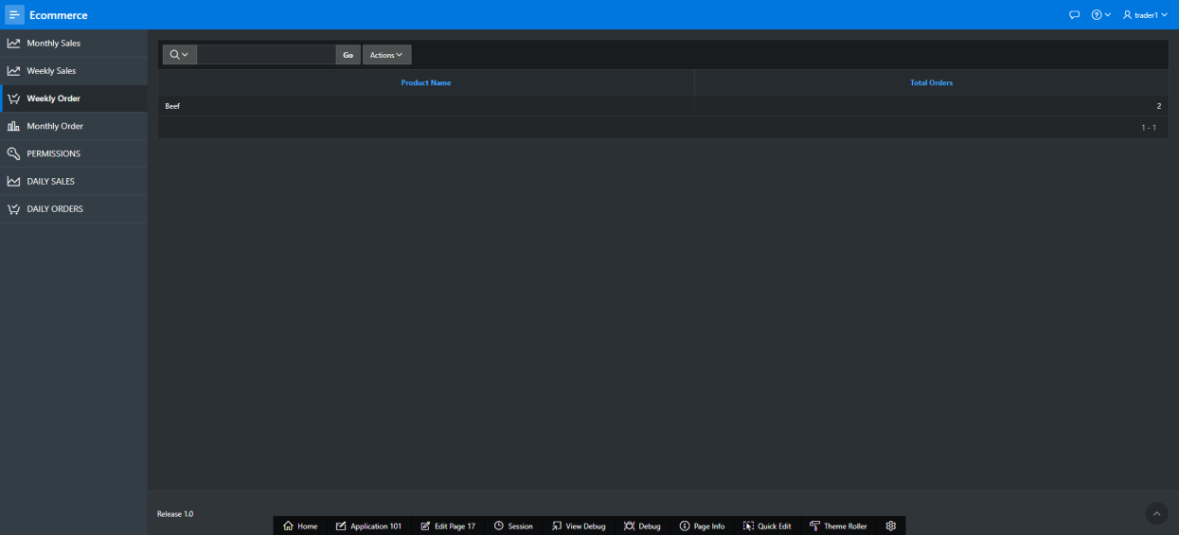

1. To view Daily order, click on Daily Orders. Daily Order report shows the products that are ordered by the customers within 24 hours.

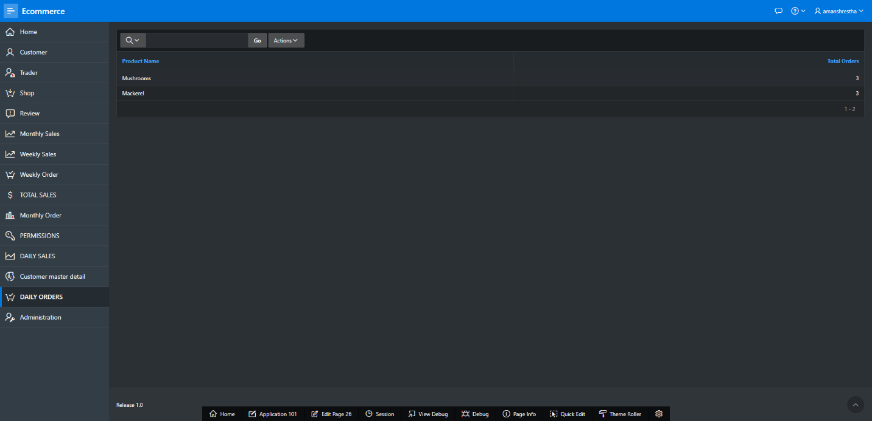

1. To view daily sales, click on Daily Sales. Daily sales shows the details of the products that are sold within 24 hours.

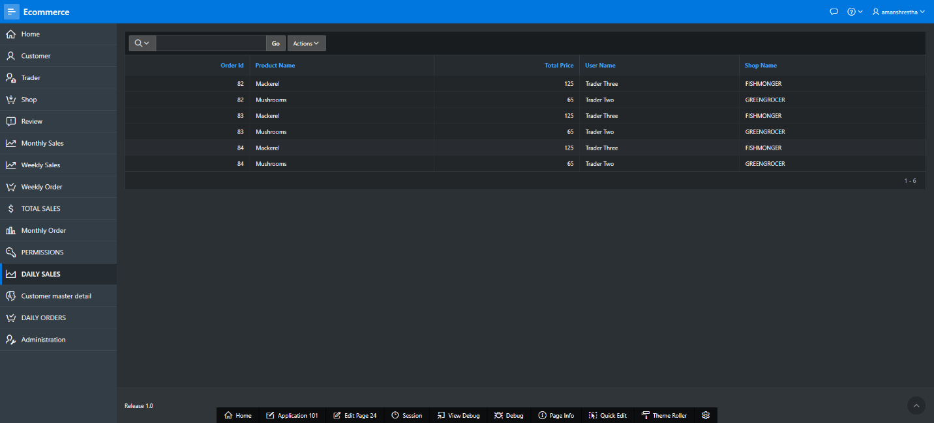

1. To view Monthly sales, click on Monthly sales. Monthly sales shows the details of the products that are sold within a month.

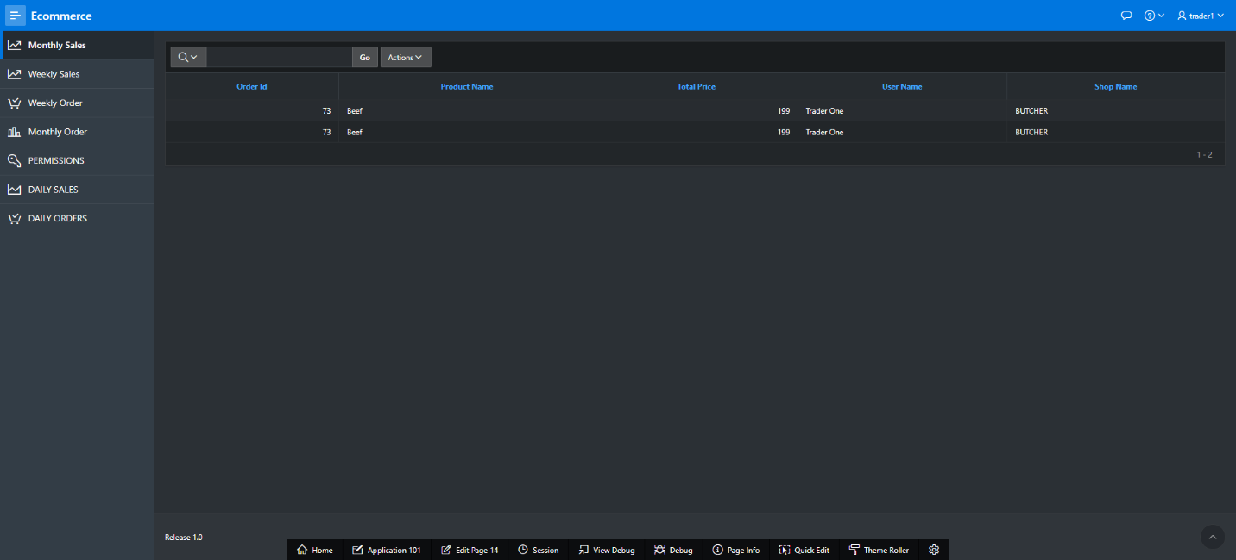

1. To view Monthly order, click on Monthly Orders. Monthly order shows the products that are ordered by the customers within a month.

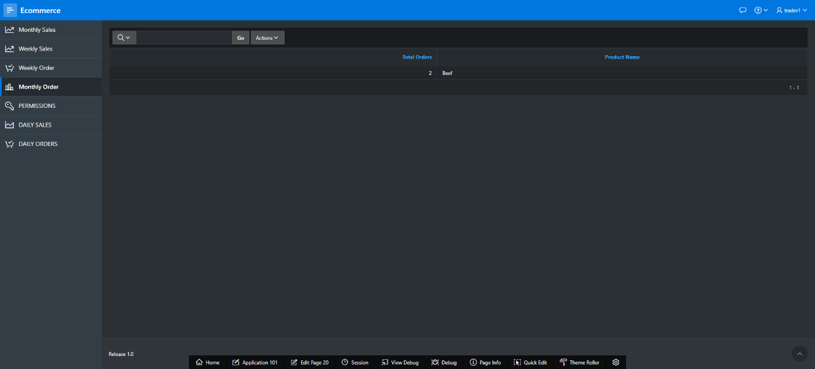

1. To logout, click the button with your name (Trader’s name) on the top right, click on sign out option.

